NAMA : DIMAS WAHYU ARDHANA

UNIVERSITAS : UNIVERSITAS DIAN NUSWANTORO

KELOMPOK : 5

LINK REPOSITORY KELOMPOK : <https://github.com/azzmnrwebdev/msib-kelompok-5>

LINK REPOSITORY BRANCH SAYA : <https://github.com/azzmnrwebdev/msib-kelompok-5/tree/DimasWArdhana>

Langkah-langkah

1. Lakukan clone pada repository
2. Setelah clone masuk ke folder, klik kanan dan klik git bash here

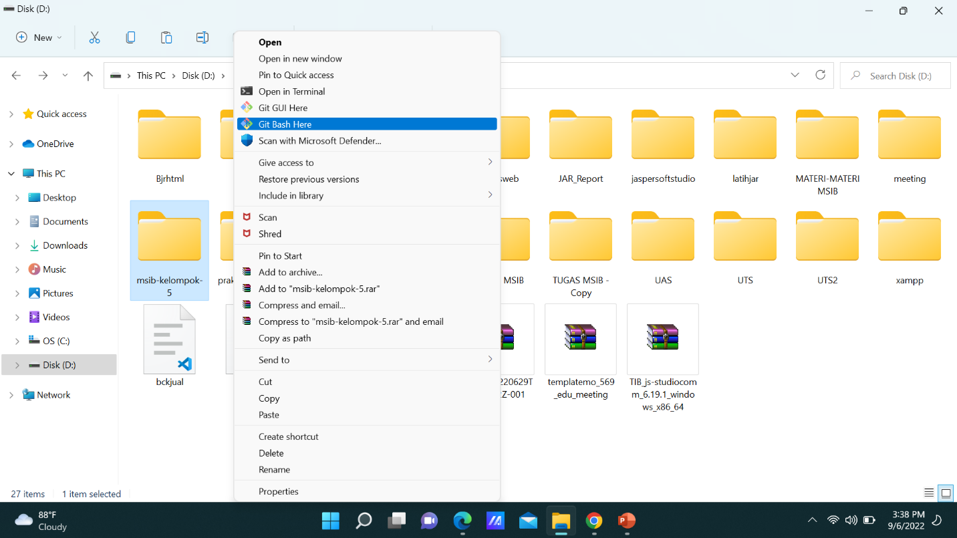

1. Setelah itu lakukan tutorial di bawah ini

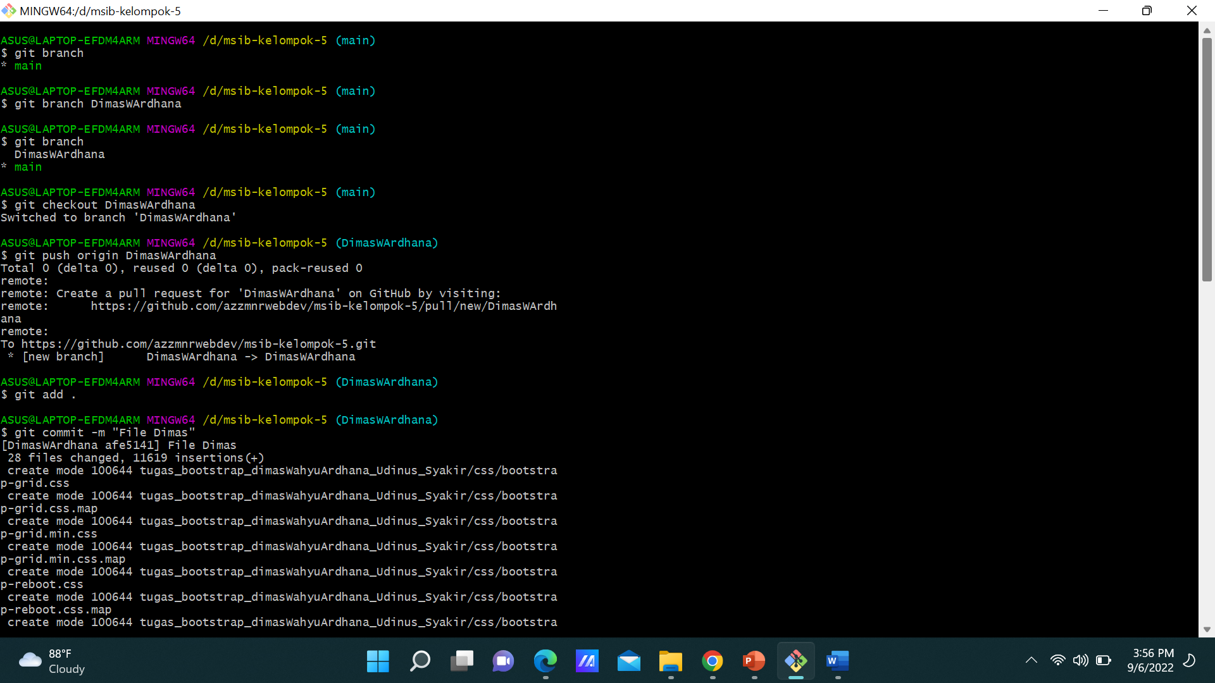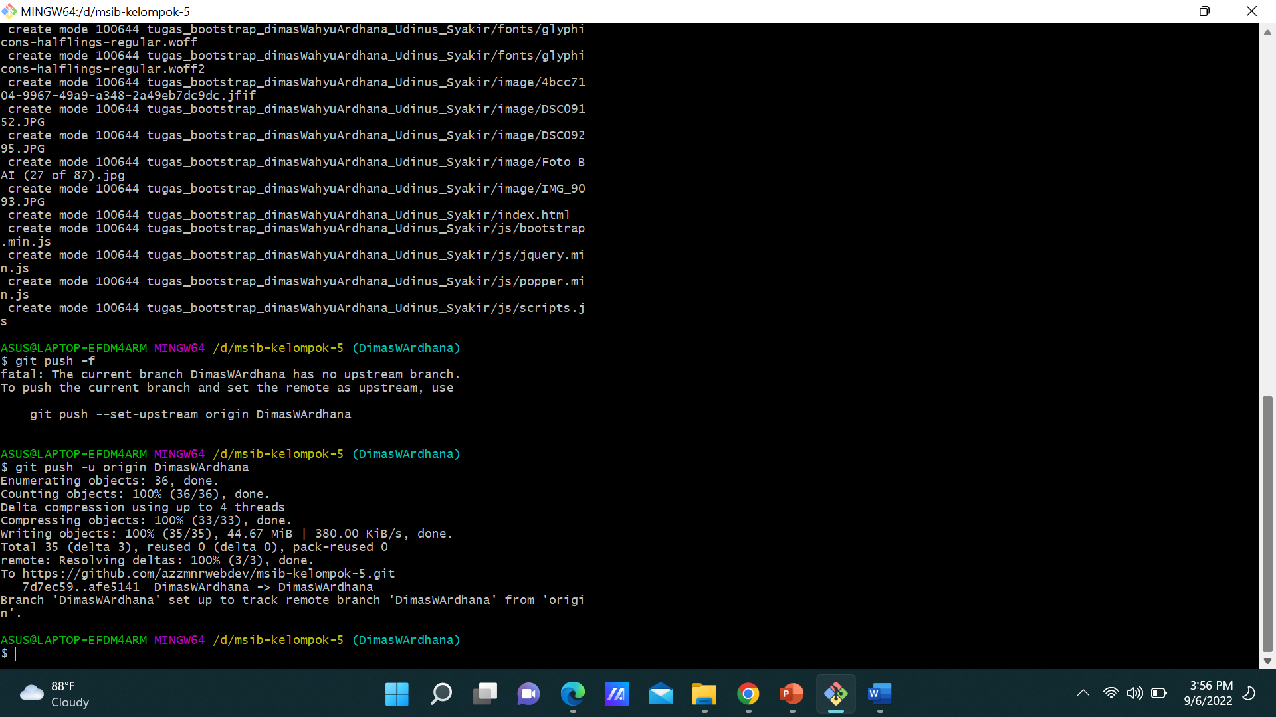

1. Atau berikut ini code-code untuk membuat branch

ASUS@LAPTOP-EFDM4ARM MINGW64 /d/msib-kelompok-5 (main)

$ git branch

* main

ASUS@LAPTOP-EFDM4ARM MINGW64 /d/msib-kelompok-5 (main)

$ git branch DimasWArdhana

ASUS@LAPTOP-EFDM4ARM MINGW64 /d/msib-kelompok-5 (main)

$ git branch

DimasWArdhana

* main

ASUS@LAPTOP-EFDM4ARM MINGW64 /d/msib-kelompok-5 (main)

$ git checkout DimasWArdhana

Switched to branch 'DimasWArdhana'

ASUS@LAPTOP-EFDM4ARM MINGW64 /d/msib-kelompok-5 (DimasWArdhana)

$ git push origin DimasWArdhana

Total 0 (delta 0), reused 0 (delta 0), pack-reused 0

remote:

remote: Create a pull request for 'DimasWArdhana' on GitHub by visiting:

remote: https://github.com/azzmnrwebdev/msib-kelompok-5/pull/new/DimasWArdhana

remote:

To https://github.com/azzmnrwebdev/msib-kelompok-5.git

* [new branch] DimasWArdhana -> DimasWArdhana

1. Masukkan code-code di bawah ini untuk repository ke branch yang kita pilih

ASUS@LAPTOP-EFDM4ARM MINGW64 /d/msib-kelompok-5 (DimasWArdhana)

$ git add .

ASUS@LAPTOP-EFDM4ARM MINGW64 /d/msib-kelompok-5 (DimasWArdhana)

$ git commit -m "File Dimas"

[DimasWArdhana afe5141] File Dimas

28 files changed, 11619 insertions(+)

create mode 100644 tugas_bootstrap_dimasWahyuArdhana_Udinus_Syakir/css/bootstrap-grid.css

create mode 100644 tugas_bootstrap_dimasWahyuArdhana_Udinus_Syakir/css/bootstrap-grid.css.map

create mode 100644 tugas_bootstrap_dimasWahyuArdhana_Udinus_Syakir/css/bootstrap-grid.min.css

create mode 100644 tugas_bootstrap_dimasWahyuArdhana_Udinus_Syakir/css/bootstrap-grid.min.css.map

create mode 100644 tugas_bootstrap_dimasWahyuArdhana_Udinus_Syakir/css/bootstrap-reboot.css

create mode 100644 tugas_bootstrap_dimasWahyuArdhana_Udinus_Syakir/css/bootstrap-reboot.css.map

create mode 100644 tugas_bootstrap_dimasWahyuArdhana_Udinus_Syakir/css/bootstrap-reboot.min.css

create mode 100644 tugas_bootstrap_dimasWahyuArdhana_Udinus_Syakir/css/bootstrap-reboot.min.css.map

create mode 100644 tugas_bootstrap_dimasWahyuArdhana_Udinus_Syakir/css/bootstrap.css

create mode 100644 tugas_bootstrap_dimasWahyuArdhana_Udinus_Syakir/css/bootstrap.css.map

create mode 100644 tugas_bootstrap_dimasWahyuArdhana_Udinus_Syakir/css/bootstrap.min.css

create mode 100644 tugas_bootstrap_dimasWahyuArdhana_Udinus_Syakir/css/bootstrap.min.css.map

create mode 100644 tugas_bootstrap_dimasWahyuArdhana_Udinus_Syakir/css/style.css

create mode 100644 tugas_bootstrap_dimasWahyuArdhana_Udinus_Syakir/fonts/glyphicons-halflings-regular.eot

create mode 100644 tugas_bootstrap_dimasWahyuArdhana_Udinus_Syakir/fonts/glyphicons-halflings-regular.svg

create mode 100644 tugas_bootstrap_dimasWahyuArdhana_Udinus_Syakir/fonts/glyphicons-halflings-regular.ttf

create mode 100644 tugas_bootstrap_dimasWahyuArdhana_Udinus_Syakir/fonts/glyphicons-halflings-regular.woff

create mode 100644 tugas_bootstrap_dimasWahyuArdhana_Udinus_Syakir/fonts/glyphicons-halflings-regular.woff2

create mode 100644 tugas_bootstrap_dimasWahyuArdhana_Udinus_Syakir/image/4bcc7104-9967-49a9-a348-2a49eb7dc9dc.jfif

create mode 100644 tugas_bootstrap_dimasWahyuArdhana_Udinus_Syakir/image/DSC09152.JPG

create mode 100644 tugas_bootstrap_dimasWahyuArdhana_Udinus_Syakir/image/DSC09295.JPG

create mode 100644 tugas_bootstrap_dimasWahyuArdhana_Udinus_Syakir/image/Foto BAI (27 of 87).jpg

create mode 100644 tugas_bootstrap_dimasWahyuArdhana_Udinus_Syakir/image/IMG_9093.JPG

create mode 100644 tugas_bootstrap_dimasWahyuArdhana_Udinus_Syakir/index.html

create mode 100644 tugas_bootstrap_dimasWahyuArdhana_Udinus_Syakir/js/bootstrap.min.js

create mode 100644 tugas_bootstrap_dimasWahyuArdhana_Udinus_Syakir/js/jquery.min.js

create mode 100644 tugas_bootstrap_dimasWahyuArdhana_Udinus_Syakir/js/popper.min.js

create mode 100644 tugas_bootstrap_dimasWahyuArdhana_Udinus_Syakir/js/scripts.js

ASUS@LAPTOP-EFDM4ARM MINGW64 /d/msib-kelompok-5 (DimasWArdhana)

$ git push -u origin DimasWArdhana

Enumerating objects: 36, done.

Counting objects: 100% (36/36), done.

Delta compression using up to 4 threads

Compressing objects: 100% (33/33), done.

Writing objects: 100% (35/35), 44.67 MiB | 380.00 KiB/s, done.

Total 35 (delta 3), reused 0 (delta 0), pack-reused 0

remote: Resolving deltas: 100% (3/3), done.

To https://github.com/azzmnrwebdev/msib-kelompok-5.git

7d7ec59..afe5141 DimasWArdhana -> DimasWArdhana

Branch 'DimasWArdhana' set up to track remote branch 'DimasWArdhana' from 'origin'.

1. Cek repository dan branch yang kita buat telah ada beserta file yang kita push

